Paired-Comparison

 | Machine 1 |  | Machine 2
 | 3.125 |  | 3.11
 | 3.12 |  | 3.095
 | 3.135 |  | 3.115
 | 3.13 |  | 3.12
 | 3.127 |  | 3.125
Media | 3.127 |  | 3.113
S.d. | 0.0057 |  | 0.0115

Tools - Data Analysis

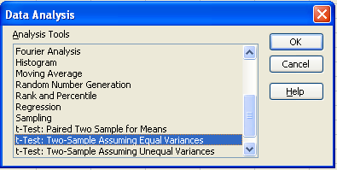

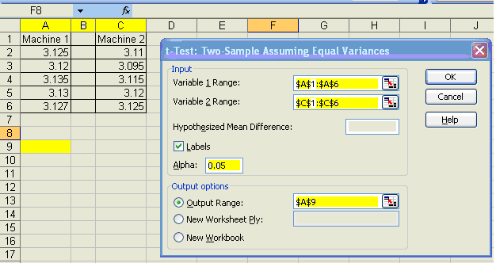

Important
- Set ranges starting where labels are
- Check Labels
- Set the alpha 0.05

OPTIONS
- 2 means Equal variances: when variances are unknown but considered equal
- 2 means Unequal variances: when variances are unknown but considered not equal

Use this option when there are few samples, so you use t-test instead of z test

Ho: μ1 = μ 2
H1: μ1 <> μ 2

t-Test: Two-Sample Assuming Equal Variances |  |  |  | t-Test: Two-Sample Assuming Unequal Variances (Most common to use)
 | Machine 1 | Machine 2 |  |  | Machine 1 | Machine 2
Mean | 3.1274 | 3.113 |  | Mean | 3.1274 | 3.113
Variance | 3.13E-05 | 0.0001325 |  | Variance | 0.000031 | 0.000132
Observations | 5 | 5 |  | Observations | 5 | 5
Pooled Variance | 8.19E-05 |  |  | Hypothesized Mean Difference | 0
Hypothesized Mean Difference | 0 |  |  | df | 6
Df | 8 |  |  | t Stat | 2.5158
t Stat | 2.5158 |  |  | P(T<=t) one-tail | 0.0227
P(T<=t) one-tail | 0.018 |  |  | t Critical one-tail | 1.9431
t Critical one-tail | 1.859 |  |  | P(T<=t) two-tail | 0.0455
P(T<=t) two-tail | 0.0360 |  |  | t Critical two-tail | 2.446
t Critical two-tail | 2.306

The critical value 2.30 / 2.44 (from table) for 2 tails at alpha 0.05

The critical values < t Stat
The null hypothesis Ho is rejected
95% confidence that the means for the 2 samples are different

Rule of thumb (not sure): P(T<=t) two tail lower than 0.05 so we reject Ho

With this option, we can check Pearson Correlation
t-Test: Paired Two Sample for Means
 | Machine 1 | Machine 2
Mean | 3.1274 | 3.113
Variance | 3.13E-05 | 0.0001325
Observations | 5 | 5
Pearson Correlation | 0.656065
Hypothesized Mean Difference | 0
Df | 4
t Stat | 3.615854
P(T<=t) one-tail | 0.01122
t Critical one-tail | 2.131847
P(T<=t) two-tail | 0.02244
t Critical two-tail | 2.776445

